1. Up to now, we saw two important things 🡺 User Detail Service and Password Encoder.
2. Let’s explore more on them along with how to create multiple users for our app.
3. 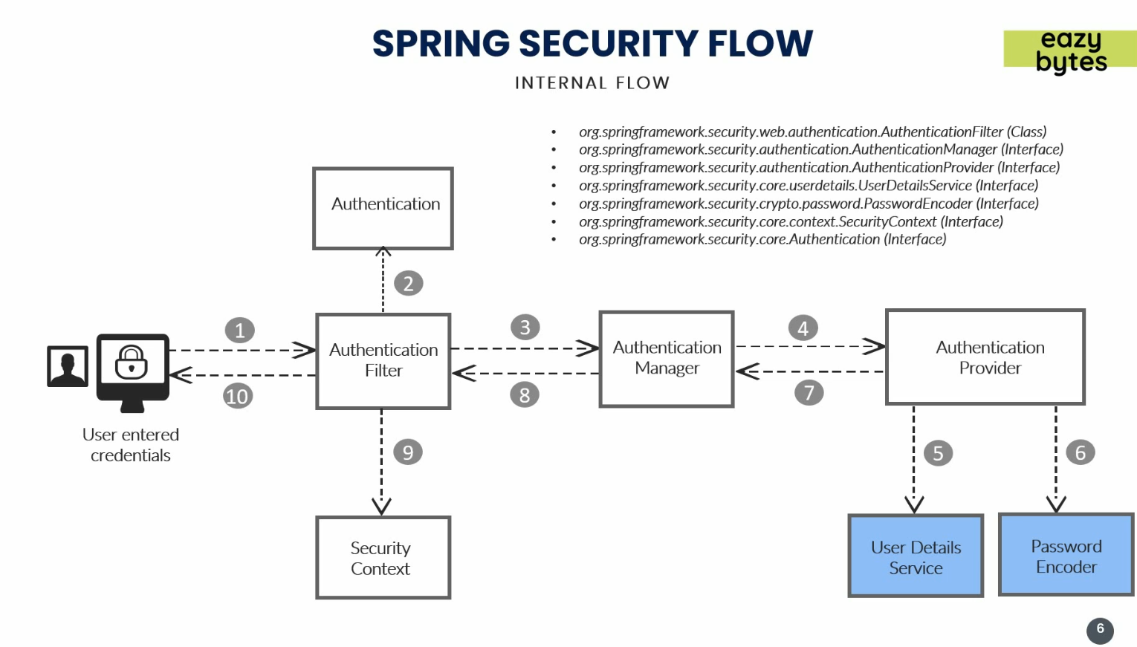
4. Till now, we had only single user configured in application.properties file.
5. 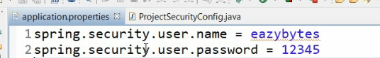
6. But our app must support as many users as we want along with their roles and authorities.
7. **Let’s configure the followings**:
   1. Users.
   2. User Details Service.
   3. Password Encoder.
   4. Authentication Provider
8. 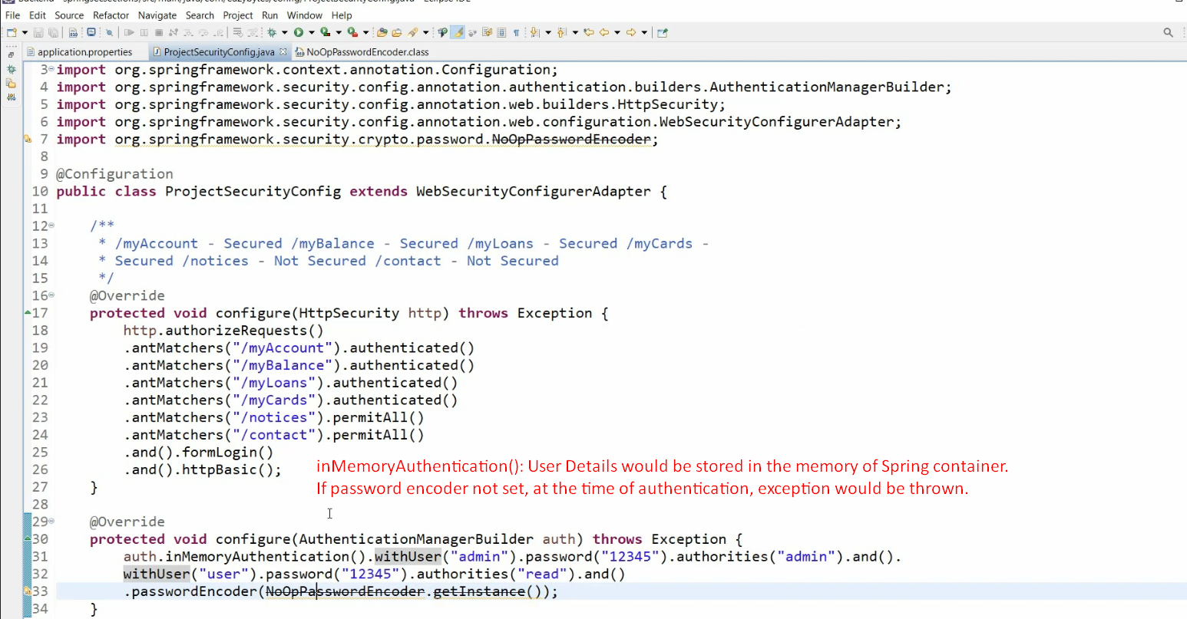
   1. **auth.inMemoryAuthentication():**
      1. This means that all the users would be stored inside the memory of spring container which will be leveraged by spring security while performing authentication and authorization details.
   2. **Password Encoder**:
      1. If not passed, at the time of authentication, spring security would throw an exception saying I don’t know how to validate your password as maybe your password is stored as a normal text, or encoded or encrypted inside the memory of spring container.  
         So, always pass password encoder.
9. 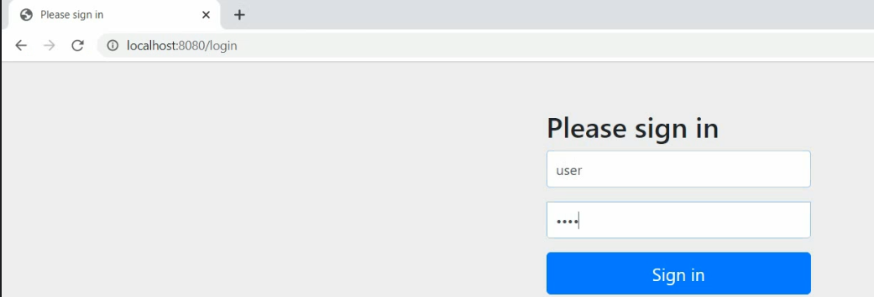
10. See, we are able to maintain a number of user details in spring security configuration.
11. This is not **Production-Ready-App**.